UNIVERSITY OF BUEA

FACULTY OF ENGINEERING AND TECHNOLOGY
DEPARTMENT OF COMPUTER ENGINEERING

CEF440: Internet Programming and Mobile Programming
COURSE INSTUCTOR: Dr. Valery Nkemeni

TASK 6: Database design and implementation
BY GROUP 3

NAMES | MATRICULE
- ABONGWA CALEB NFORNGWA | FE22A133
- BEKONO AKONO MARTHE LUNYA LAWRICA | FE22A171
- MUKETE ATIA HANS MASANGO | FE22A250
- NGUIMFACK AZAFACK JOREL | FE22A267

Academic Year (2024/2025)

TABLE OF CONTENTS
TASK 6: Database design and implementation 1
Monitoring App 2
Data Elements 3
1. User 3
2. Network Metrics 3
3. Feedback Reports 4
4. Alerts 4
5. Operator 4
6. Regulatory Reports 5
Conceptual Design 5
Key conceptual components: 6
Entity Relationship Diagram (ERD) 6
Relationships: 7
1. Privacy Controls: 8
2. Performance Optimization: 8
3. Security Measures: 8
4. Data Retention Policies: 8
Database Implementation Report 8
Project Overview 8
Database Choice: MongoDB 8
Rationale 9
Database Models 9
Database Connection 10
CRUD Operations 10
Backend Implementation Report 11
Middleware and Utilities 13
Security Considerations 14
Connecting Database to Backend 14
Overview 14
Summary 15

Database design and implementation

Data Elements, Conceptual Design, and Entity Relationship Diagram for "Checkin" Mobile Network Monitoring App

This section outline the data elements, conceptual design, and ER diagram for the "Checkin" application.

Data Elements

Data Elements are the basic units of data with a defined meaning and structure. They represent a single piece of information, such as:

- Name

- Age

- Phone number

- Date of birth

Each data element usually has:

- A name (e.g., "EmailAddress")

- A data type (e.g., String, Integer)

- Constraints (e.g., must be unique, not null)

1. User

- user_id (PK): Unique identifier (UUID)

- username: String (50 chars)

- email: String (100 chars), validated

- password_hash: String (hashed)

- preferred_language: Enum ('en', 'fr')

- notification_preferences: Boolean (default true)

- data_sharing_preferences: Boolean (default true)

- created_at: Timestamp

- last_login: Timestamp

2. Network Metrics

- metric_id (PK): Unique identifier (UUID)

- user_id (FK): References User

- download_speed: Float (Mbps)

- upload_speed: Float (Mbps)

- latency: Integer (ms)

- signal_strength: Integer (dBm)

- network_type: Enum ('2G', '3G', '4G', '5G', 'WiFi')

- carrier: String (50 chars)

- location_latitude: Float (nullable)

- location_longitude: Float (nullable)

- timestamp: Timestamp

3. Feedback Reports

- report_id (PK): Unique identifier (UUID)

- user_id (FK): References User

- rating: Integer (1-5)

- comments: Text (nullable)

- screenshot_url: String (nullable)

- location_latitude: Float (nullable)

- location_longitude: Float (nullable)

- status: Enum ('Pending', 'In Progress', 'Resolved', 'Rejected')

- created_at: Timestamp

- updated_at: Timestamp

- operator_notes: Text (nullable)

4. Alerts

- alert_id (PK): Unique identifier (UUID)

- user_id (FK): References User

- alert_type: Enum ('Low Signal', 'High Latency', 'Slow Speed', 'Outage', 'Maintenance')

- message: String (255 chars)

- severity: Enum ('Low', 'Medium', 'High', 'Critical')

- is_read: Boolean (default false)

- created_at: Timestamp

- dismissed_at: Timestamp (nullable)

5. Operator

- operator_id (PK): Unique identifier (UUID)

- name: String (100 chars)

- contact_email: String (100 chars)

- service_area: String (100 chars)

- is_active: Boolean (default true)

6. Regulatory Reports

- report_id (PK): Unique identifier (UUID)

- period_start: Date

- period_end: Date

- average_download_speed: Float

- average_upload_speed: Float

- average_latency: Float

- outage_count: Integer

- complaint_count: Integer

- generated_at: Timestamp

- operator_id (FK): References Operator (nullable for aggregate reports)

Conceptual Design

Conceptual Design is the high-level process of defining the structure and meaning of the data in a system without focusing on how it will be physically implemented. It’s typically represented using Entity-Relationship (ER) diagrams, and its goal is to clearly understand and represent business requirements in data terms before moving to logical or physical design.

It includes:

- Entities (e.g., Student, Course)

- Attributes (e.g., Name, ID)

- Relationships (e.g., a student enrolls in courses)

The "Checkin" application follows a user-centric design with three main user roles:

1. Mobile Subscribers: Primary users who monitor their network quality and submit feedback

2. Network Operators: Secondary users who receive aggregated reports and individual feedback

3. Regulatory Authorities: Tertiary users who receive anonymized aggregate data for compliance monitoring

Key conceptual components:

1. Network Monitoring: Continuous background collection of network metrics (speed, latency, signal)

2. Feedback System: User-submitted reports about network issues with optional location data

3. Alert System: Notifications about network conditions or responses to feedback

4. Reporting: Historical views of both metrics and feedback for all user types

5. Settings Management: User preferences for privacy, notifications, and language

Entity Relationship Diagram (ERD)

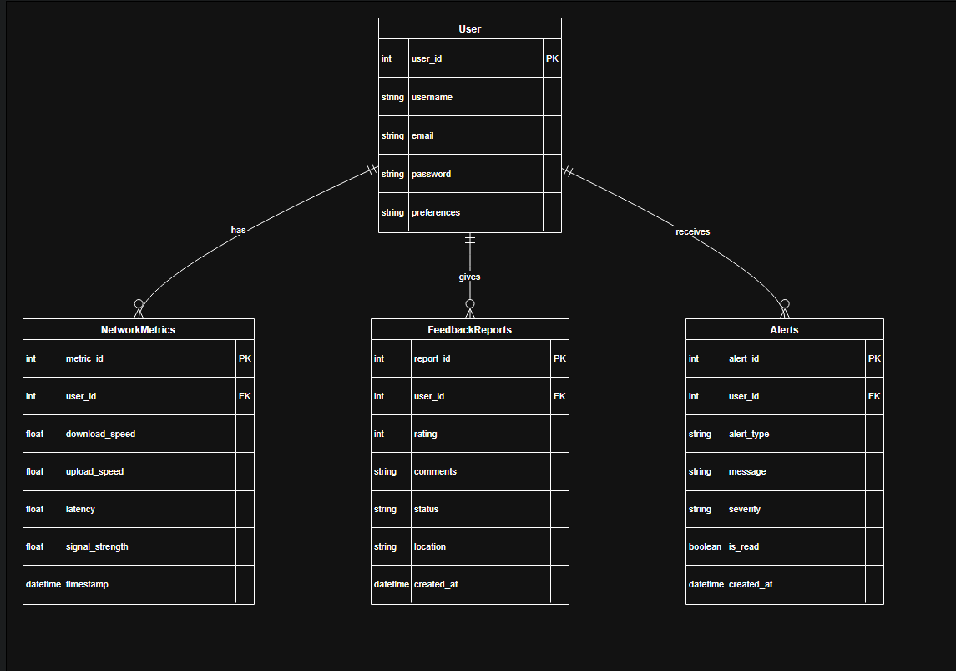

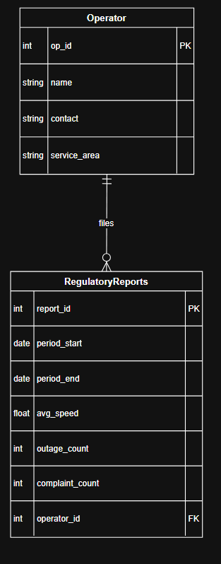

Relationships:

1. User to NetworkMetrics: One-to-Many (A user can have many network metric records)

2. User to FeedbackReports: One-to-Many (A user can submit many feedback reports)

3. User to Alerts*: One-to-Many (A user can receive many alerts)

4. FeedbackReports to NetworkMetrics: Many-to-One (Optional - Feedback can reference specific metrics)

5. Operator to RegulatoryReports: One-to-Many (An operator can have many regulatory reports)

6. RegulatoryReports to FeedbackReports: Indirect aggregation (Reports summarize feedback data)

Additional Design Considerations

1. Privacy Controls:

- Location data is optional and requires explicit user consent

- Data sharing preferences control what information is sent to operators/regulators

- Anonymization for regulatory data exports

2. Performance Optimization:

- Network metrics are batched for transmission to reduce battery/data usage

- Local caching of recent metrics and reports

- Indexing on frequently queried fields (user_id, timestamps)

3. Security Measures:

- All sensitive data (user info, location) is encrypted at rest and in transit

- Role-based access control for operator/regulator views

- Audit logging for all data modifications

4. Data Retention Policies:

- Raw network metrics retained for 30 days (for user review)

- Aggregated metrics retained for 1 year

- Feedback reports retained indefinitely (with status tracking)

This design supports all the functionality shown in the UI screens (dashboard, feedback form, report history, settings, and alerts) while maintaining scalability for future enhancements.

Database Implementation Report

Project Overview

This report describes the database implementation for the "Network Alerts & Diagnostics" project, which provides a backend API to collect, store, and retrieve user feedback, network speed test results, and diagnostic trends. The backend is built with Node.js and Express, and MongoDB is used as the primary database.

Database Choice: MongoDB

Rationale

MongoDB is a NoSQL, document-oriented database designed to store data in flexible, JSON-like documents. We chose MongoDB for several reasons:
- Schema Flexibility: Our use case requires storing diverse types of data (feedback, speed tests, network trends), each with different structures. MongoDB's flexible schemas accommodate this without requiring complex migrations.
- Scalability: MongoDB scales easily as data grows, supporting horizontal scaling and high availability.
- JSON-Like Storage: Since our frontend and backend communicate using JSON, storing data as BSON (binary JSON) in MongoDB enables a seamless and natural mapping.
- Rapid Development: MongoDB integrates easily with Node.js using the Mongoose ODM, enabling fast development cycles and easy data validation.

Database Models

The backend defines three main Mongoose models, each corresponding to a MongoDB collection:

1. Feedback

- Purpose: Stores user-submitted feedback about network issues.
- Fields:
  - issueType (String): The category of the issue (required).
  - customIssue (String): Further description if the issue is "Other".
  - comments (String): User comments (required).
  - location (Object): Includes latitude, longitude, and address.
  - screenshot (String): (Optional) Base64-encoded image.
  - submittedAt (Date): Timestamp of submission (defaults to current date/time).

2. SpeedTest

- Purpose: Stores results from user network speed tests.
- Fields:
  - userId (String): (Optional) User identifier.
  - downloadSpeed, uploadSpeed (Number): Measured in Mbps (required).
  - latency, jitter (Number): Network quality metrics (required).
  - networkType (String): E.g., "wifi", "cellular" (required).
  - carrier (String): Network provider (required).
  - testedAt (Date): When the test was performed (defaults to now).

3. NetworkTrend

- Purpose: Tracks the user's network status over time for diagnostics.
- Fields:
  - status (String): E.g., "online", "offline" (required).
  - timestamp (String): ISO time of the status (required).
  - type (String): Network type (required).
  - Additional optional fields: isConnected, isInternetReachable, ipAddress, strength, cellularGeneration, downlink, uplink.

Database Connection

The backend uses the Mongoose library to connect to MongoDB. The connection string is loaded from an environment variable (MONGODB_URI) for security and flexibility. This allows easy switching between development and production databases.
mongoose.connect(MONGODB_URI)
.then(() => {
app.listen(PORT, () => {
console.log(`Server listening on port ${PORT}`);
});
})
.catch((err) => {
console.error("Failed to connect to MongoDB:", err);
process.exit(1);
});

CRUD Operations

- Create: Data is inserted into MongoDB when the frontend submits feedback, speed test, or network trend information. Each submission creates a new document in the relevant collection.
- Read: The backend supports API endpoints to retrieve the most recent feedback, speed tests, and diagnostic trends, either globally or per user.
- Update / Delete: Not implemented, as the application focuses on historical data collection rather than modification.

Example Data

Feedback document:
{
"issueType": "Network Down",
"comments": "Network has been unstable.",
"location": {
"latitude": 5.12,
"longitude": 10.43,
"address": "Yaounde, Cameroon"
},
"screenshot": "",
"submittedAt": "2025-06-10T04:10:00Z"
}
SpeedTest document:
{
"userId": "user1",
"downloadSpeed": 30,
"uploadSpeed": 10,
"latency": 80,
"jitter": 12,
"networkType": "wifi",
"carrier": "MTN",
"testedAt": "2025-06-10T04:10:10Z"
}

Backend Implementation Report

Technology Stack
- Node.js: JavaScript runtime environment for server-side logic.
- Express.js: Web framework for building RESTful APIs efficiently.
- MongoDB: NoSQL database for flexible and scalable data storage.
- Mongoose: ODM (Object Data Modeling) library for MongoDB and Node.js.
- CORS: Middleware to enable Cross-Origin Resource Sharing.
- dotenv: Loads environment variables for secure configuration.
API Design and Endpoints
The backend exposes several endpoints to facilitate data submission and retrieval:

1. Health Check Endpoint
GET /api/health
  - Verifies server status and connectivity.
  - Returns a JSON response indicating API health.

2. Feedback Endpoints
POST /api/feedback
  - Receives user feedback on network issues.
  - Validates input and saves it to MongoDB.
  - Logs each submission for monitoring and debugging.
GET /api/feedback
  - Retrieves the latest 20 feedback submissions from the database.

3. Speed Test Endpoints
POST /api/speedtest
  - Stores results from user-performed speed tests, including download/upload speeds, latency, jitter, network type, and carrier.
  - Input is validated before storage.
GET /api/speedtest
  - Fetches the 20 most recent speed test results.
GET /api/speedtest/history/:userId
  - Retrieves the last 20 speed test results for a specific user.

4. Network Trend Endpoints

POST /api/network-trend
  - Logs a single network status datapoint for diagnostics.
GET /api/network-trend
  - Retrieves up to 24 recent network trend samples (for visualization).

Combined Diagnostics Endpoint

POST /api/diagnostics
Accepts a payload containing any combination of feedback, speed test, and network trend data.
Each section is independently validated and stored in the corresponding MongoDB collection.
Logs every submission for traceability.

Middleware and Utilities

- CORS Middleware: Allows requests from different origins (essential for frontend-backend communication, especially during development).
- Body Parser: express.json({ limit: '10mb' }) is used to handle large payloads, such as screenshots or diagnostic data.
- Environment Variables: Sensitive data like database URIs and server ports are managed via a .env or url.env file and loaded with dotenv.

Logging and Error Handling

- All POST endpoints log incoming requests to the terminal, enabling real-time monitoring of API usage and easy debugging.
- Input data is validated before being written to the database, preventing malformed or incomplete records.
- Server-side errors are caught, logged, and an appropriate error message is sent to the client.

Server Initialization

- The server connects to MongoDB using credentials from environment variables.
- On successful connection, it starts listening on the specified port (4000 by default).
- A failed database connection logs an error and exits the process to avoid running the API without persistence.

Example: Server Startup Code

mongoose
.connect(MONGODB_URI)
.then(() => {
app.listen(PORT, () => {
console.log(`Server listening on port ${PORT}`);
});
})
.catch((err) => {
console.error("Failed to connect to MongoDB:", err);
process.exit(1);
});

Security Considerations

- All environment-specific values are stored outside the codebase.
- The API validates incoming data rigorously to prevent injection and malformed requests.
- CORS settings can be adjusted for production deployment as needed.

Connecting Database to Backend

Steps to Connect MongoDB Database to Backend

1. Install Required Packages

Install the necessary Node.js packages with:
npm install mongoose dotenv
- mongoose: ODM library for MongoDB and Node.js.
- dotenv: Loads environment variables from a .env or (url.env) file for secure configuration

2. Configure Environment Variables

Create a file named .env or url.env in your project root and add:
MONGODB_URI=your_mongodb_connection_string
PORT=4000
- MONGODB_URI: The MongoDB connection string (can be local or from a cloud service like MongoDB Atlas).
- PORT: The port number for your backend server.

3. Load Environment Variables in Backend

At the top of your server.js:
const dotenv = require("dotenv");dotenv.config({ path: "url.env" }); // or ".env" if that's your file

4. Connect to MongoDB with Mongoose

Add the following code in your server.js before starting the Express server:
const mongoose = require("mongoose");
// Fetch connection string from environment variablesconst MONGODB_URI = process.env.MONGODB_URI || "";
// Connect to MongoDBmongoose
.connect(MONGODB_URI)
.then(() => {
app.listen(PORT, () => {
console.log(`Server listening on port ${PORT}`);
});
})
.catch((err) => {
console.error("Failed to connect to MongoDB:", err);
process.exit(1);
});

5. Define Mongoose Models

Create Mongoose schemas and models for each data type (e.g., Feedback, SpeedTest, NetworkTrend):
const FeedbackSchema = new mongoose.Schema({
issueType: { type: String, required: true },
comments: { type: String, required: true },
// ... other fields});const Feedback = mongoose.model("Feedback", FeedbackSchema);
Repeat for other entities.

6. Use Models in API Endpoints

Within your Express routes, use the models to save and retrieve data:
// Save feedback dataapp.post("/api/feedback", async (req, res) => {
try {
const feedback = new Feedback(req.body);
await feedback.save();
res.status(201).json({ message: "Feedback submitted successfully", feedback });
} catch (err) {
res.status(500).json({ message: "Server error" });
}});

Summary

- Use Mongoose to connect your Node.js backend to MongoDB.
- Store your database URI in a secure .env or url.env file.
- Load environment variables with dotenv.
- Define Mongoose schemas/models for your data.
- Use these models in your Express routes to interact with your database.

Conclusion

To conclude, the above steps and activities where taken to implement our database, backend and link these 2 .this project was implemented succesfully and we are looking forward to deploy it.

